RESOLUTION NO.__________

RE: CERTIFICATE OF APPROPRIATENESS UNDER THE
PROVISIONS OF THE ACT OF THE PENNSYLVANIA
LEGISLATURE 1961, JUNE 13, P.L. 282 (53
SECTION 8004) AND BETHLEHEM ORDINANCE NO.
3952 AS AMENDED.

WHEREAS, it is proposed to install a sign on an existing bracket and add text/logo window clings to the windows and the front door at 451 Main St. (The Flying Egg)

NOW, THEREFORE, BE IT RESOLVED by the Council of the City of Bethlehem that a Certificate of Appropriateness is hereby granted for the proposal.

Sponsored by: (s)

(s)

ADOPTED BY COUNCIL THIS DAY OF

(s)
President of Council

ATTEST:

(s)
City Clerk

HISTORICAL & ARCHITECTURAL REVIEW BOARD

The applicant is proposing to install a sign on an existing bracket and add text/logo window clings to the windows and the front door at 451 Main St. (The Flying Egg)
APPLICATION #2:

Tony Mauser
451 Main St.
Bethlehem, PA 18018

OWNER:

__________________________________________________________________________

The Board upon motion by Gen Marcon and seconded by Beth Starbuck adopted the proposal that City Council issue a Certificate of Appropriateness for the following:

- Change the background on the blade sign to black with orange color of egg
yolk to pin stripe.
- Relocate “Boutique Diner” to mid-level of the window.
- To use vinyl die cut letters on the sign background.
- Add text/logo window clings to the window and front door.
5. The motion was unanimously approved.
__________________________________________________________________________

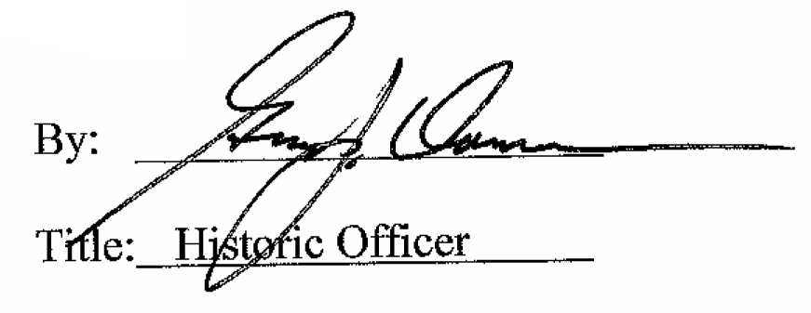

Date of Meeting: April 5, 2017

